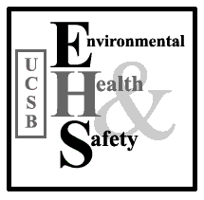
JOB HAZARD ANALYSIS (JHA) JHA#

Certification of Hazard Assessment

Job Title or Task:

Department:

Title of person(s) performing this job/task:

JHA Created by:
Date:

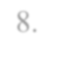
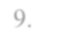
JHA Approved/Certified by:
Date:

Task Step (Sequence) | Known or Potential Hazard(s) | Controls (Preventive or Corrective Action)
1.
2.
3.
4.
5.
6.
7.
8.
9.

If required, continue steps on next page

10.
11.
Required Training |  | Minimum Required Personal Protective Equipment
Minimum :  -All UCCS-required basic employee safety training  - Anyone performing this task, must be trained on these JHA provisions Additional:  -  -  - |  | Circle All That Apply
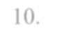
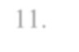
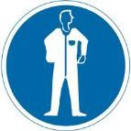
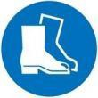
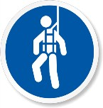
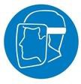
Use the space below or additional pages to attach pictures, diagrams, or other relevant information.

